Standard Operating Procedures for the LAKANA trial
SOP Lab-12 Extraction of E.coli DNA for genotypic analysis
Version 1.0 (2023-07-05)

Purpose and overview:
This Standard Operating Procedure (SOP) explains how to extract DNA from E.coli cultures for subsequent genotypic analysis as part of the antimicrobial resistance (AMR) sub-study of the LAKANA trial.

2. Applicability to and responsibilities of various staff members
Staff member | Responsibility
Laboratory technician | - Culture of E.coli samples  - DNA extraction of E.coli samples and aliquoting of DNA  - Maintaining enough laboratory consumables in the laboratory  - Accurately recording the DNA samples and appropriate storage

3. Required materials
Item | Number | Specification
Disinfectant | 1 | 10% bleach and 70% ethanol
Vortex | 1 | None
Microfuge | 1 | To take 2ml screw-cap tubes, speed up to 13,000rpm
Tissue Lyser | 1 | e.g. Qiagen
Heat block | 1 | 56ºC
Pipette set | 1 | 1x P1000, 1xP200, 1xP20
Pipette Tips (with filter) |  | P1000, p20-200
Lysing Matrix B | 1/6 vial/ sample | MPbio (116911500)
QiaAmp DNA Mini-kit |  | Qiagen (51306)
2mL screw cap tube with o-ring which can be used in a bead beater | 1/sample | 2mL screw cap tubes such as Sarstedt (72.694.406)
1.5mL Microfuge tubes (DANse/RNAse free | 2/sample | e.g. Eppendorf (2027-07-28)
Permanent marker | 1 | None
Ethanol |  | Molecular grade
Biohazard waste containers | 1 | None

4. Definitions and general instructions

4.1. Definitions

4.1.2. Laboratory technician: a staff member in the laboratory responsible for processing, storage and analysing LAKANA study samples.

4.2. General Instructions/Overview

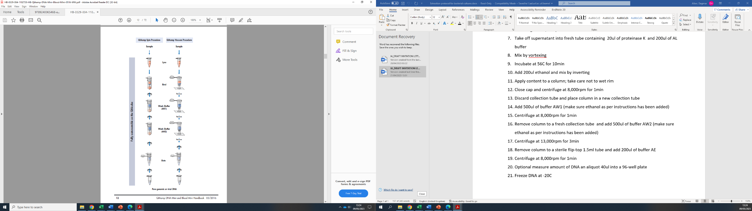
4.2.1. DNA will be extracted from overnight cultures using a modified QIAamp DNA mini kit protocol
Ribolyse

5. Step-by-step procedures

5.1. Preparation of extraction area

5.1.1. Make sure the extraction area is thoroughly cleaned with 10% bleach/70% ethanol. An extraction area which is separate from bacterial culture and post-PCR should be chosen to minimize cross-contamination.

Pipettes should only be used for extraction. Do not use pipettes that have previously been used for post-PCR sample manipulation.
    - Set heating block to 56ºC
    - Make sure AE buffer is at room temperature
    - Ensure that 100% ethanol has been added to buffer AW1 and AW2 (for the amount, please see instructions on the bottle. Once added tick the ‘yes’ box on the lid, add date)
    - If a precipitate has formed in the buffer AL, dissolve by incubating at 56 ºC.

  - DNA extraction
    - To a 2ml screw cap tube, add approximately 1/6 of a tube of lysing matrix B and 200µL of AE buffer.
    - With a 10µL bacterial loop, pick up a streak of bacteria (a loop full) from an overnight E.coli isolate culture plate (please see LAKANA_Trial_SOP_Lab-05_E.coli culture) and place into the screw cap tube containing the lysing matrix beads and AE buffer (5.2.1). Dislodge the bacteria from the loop and close the cap of the tube.
    - Label the tube with the E.coli ID number
    - Vortex for 10sec.
    - Repeat steps 5.2.1-5.2.3 for each sample to be extracted.
    - Add a negative extraction control for each set of extractions by adding approximately 1/6 of tube of lysing matrix B and 200µL of AE buffer to a fresh 2ml screw cap tube. Label this tube with ‘ex and the date’
    - Bead beat samples at 50osc for 2min using the TissueLyser.
    - Briefly centrifuge the tube to remove drops from the inside of the lid
    - For each sample label a fresh 2mL screw cap tube with the sample ID. Pipet 20µl of proteinase K into the bottom of each tube
    - Transfer all supernatants from 5.2.8 into a separate tube containing proteinase K
    - Add 200 µl of buffer AL to each tube. Important: Buffer AL should not directly get in contact with proteinase K, as this inactivates the enzyme. Close the tubes
    - Mix by pulse vortexing for 15sec
    - Incubate at 56ºC for 10min
    - Briefly centrifuge the tube to remove drops from the inside of the lid
    - Add 200ul ethanol and mix by inverting or by pulse-vortexing no longer than 10sec.
    - Briefly centrifuge the tube to remove drops from the inside of the lid
    - Carefully apply each sample mixture from step 5.2.15 to a spin column (labelled on the lid with the appropriate ID number); take care not to wet rim
    - Close cap and centrifuge at 8,000rpm for 1min
    - Discard collection tube with filtrate and place column in a new 2ml collection tube. If not all liquid has passed through the column, re-centrifuge for 1min at 8000rpm, discard the collection tube and place column in a new 2ml collection tube. If the problem persists increase the centrifugation step to 13,000rpm.
    - Add 500µL of buffer AW1 (make sure ethanol has been added as per instruction)
    - Centrifuge at 8,000rpm for 1min
    - Discard collection tube containing the filtrate and place the spin column in a fresh collection tube and add 500 µL of buffer AW2 (make sure ethanol has been added as per instruction)
    - Centrifuge at 13,000rpm for 3min
    - Discard the collection tube containing the filtrate and place the spin column in a new 2mL collection tube
    - Centrifuge at full speed for 1min.
    - Discard 2ml collection tube containing the filtrate and place column in a labelled, clean flip-top 1.5ml Eppendorf tube and add 200µL of buffer AE.
    - Let the spin columns stand for 2min at room temperature.
    - Centrifuge at 8,000rpm for 1min
    - Measure the DNA concentration using a Qubit fluorometer (a minimum of 4ng/µL is expected) and prepare 2 aliquots (100 µL each)
    - Freeze DNA at -20˚C

Occupational Safety Issues

All study team members undertaking this SOP must be trained in good clinical laboratory practice

All study team members must handle all E.coli isolates with care and treat them as infectious material.

Quality Assurance / Quality Control
All involved study personnel who will handle E.coli cultures undergo practical training. Study personnel will not be approved to extract DNA until a laboratory supervisor has assessed their competency and signed off the training log.

Appendices and other related documents
Document number | Document content
Appendix 1 | QIAamp DNA Mini Handbook
Appendix 2 | LAKANA_Trial_SOP_Lab-05_E.coli culture
*The appendices not included in this SOP. The lab has all the appendixes.

Version history, authors and approvals
Version (date) | Edits to the SOP text (author)
1.0 (2023-07-05) | Authored by Dagmar Alber in consultation with Elaine Cloutman-Green, Jane Juma, Awa Traore and Yuemei Fan.

Abbreviations: AMR = antimicrobial resistance, DCF = Data collection form, DESS = DMSO/EDTA/saturated sodium chloride, LAKANA = Large-scale assessment of the key health-promoting activities of two new mass drug administration regimens with azithromycin, PID = participant identification, SOP = Standard operating procedure

