Standard Operating Procedures for the LAKANA trial

**SOP Lab-07 E.coli AMR testing**

Version 1.0 (2022-06-22)

# Purpose and overview:

The purpose of this Standard Operating Procedure (SOP) is to describe how to perform the antimicrobial susceptibility testing for *E.coli* using an antimicrobial disc assay and E-test.

Disc diffusion is one of the oldest approaches to antimicrobial susceptibility testing and remains one of the most widely used antimicrobial susceptibility testing methods. As with all methods, the described technique must be followed without modification in order to produce reliable results.

The method follows the guidelines set by European Committee on Antimicrobial Susceptibility Testing (EUCAST) Antibiotic impregnated into paper discs is allowed to diffuse into agar previously inoculated with the organism under test. Where the organism is susceptible to the antibiotic, it will be inhibited from growing around the disc. The size of the zone of inhibition, when compared to standard zone size tables (EUCAST, [http:/w/ww.eucast.org](http://ww.eucast.org)) indicates whether the isolate is Sensitive (likely to respond to treatment) or Resistant (unlikely to respond to treatment). Isolates that fall into the intermediate area between the two, i.e. not completely sensitive, but also not fully resistant, are classed as Intermediate. *E.coli isolates* will also be tested for erythromycin by E-test to determine the minimum inhibitory concentration (MIC, lowest concentration of antimicrobial that will inhibit the visible growth of a micro-organism after overnight incubation) against azithromycin.

The E-test gradient technology is based on a combination of the concepts of dilution and diffusion principles for susceptibility testing. As with other dilution methods they directly quantify antimicrobial susceptibility in terms of discrete MIC values. E-test are thin, inert and non-porous plastic strips. One side of the strip (A) carries the MIC reading scale in µg/mL and a two or three-letter code on the handle to designate the identity of the antibiotic. A predefined exponential gradient of antibiotic, dried and stabilised, is immobilised on the other side of the strip (B) with the concentration maximum at a, and the minimum at b (Figure 1). The gradient covers a continuous concentration range across 15 two-fold dilutions of a conventional MIC method.

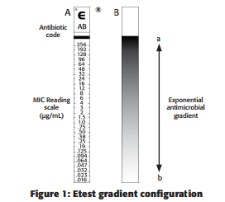

When a gradient strip is applied to an inoculated agar surface, there is immediate and effective transfer of the preformed antibiotic gradient on the plastic carrier surface into the agar matrix. A stable, continuous and exponential gradient of antibiotic concentrations is formed directly underneath the strip. After incubation, whereby growth becomes visible, a symmetrical inhibition ellipse centred along the strip is seen. The MIC value is read from the scale in terms of µg/mL where the pointed end of the ellipse intersects the strip.

# Applicability to and responsibilities of various staff members

|  |  |
| --- | --- |
| **Staff member** | **Responsibility** |
| Laboratory technician/scientist | * Maintaining sufficient supply of materials and reagents in the testing laboratory * Performing the antimicrobial susceptibility test using good aseptic techniques * Recording results |

# Required materials

| **Item** | **Number** | **Specification** |
| --- | --- | --- |
| *Escherichia coli*  reference strain ATCC 25922 | 1 | As reference strain |
| Sensitivity agar: | Well supplied | Mueller-Hinton agar |
| E-test | Well supplied | For example Biomerieux ETEST® AZITHROMYCIN AZ 256 US  SKU Number : 412256 |
| Sterile cotton swabs | Well supplied | None |
| Bunsen Burner |  | None |
| Bacterial loops | Well supplied | 10µl |
| Remel McFarland Equivalence Turbidity Standard Set | 1 | For example, Thermo Fisher R20421 |
| Waste Pot |  | None |
| Culture Agar Rack |  | None |
| Calibrated ruler | 1 | None |
| Antibiotic templates | 1 | <http://www.bsac.org.uk/susceptibility/template-program> |
| Incubator | 1 | 34-36oC |
| Autoclave |  |  |
| Balance | 1 | mg-gram |
| Measuring cylinder |  | 1l |
| Glass bottles |  | 500ml-1l need to be autoclavable |
| Petri dishes | Well supplied | 90mm |
| Sterile tubes with saline | Well supplied | Tube size is 15 x 103mm with 3-5ml sterile saline |
| Azithromycin E-test strips | 1 per *E.coli* sample | e.g. biomerieuxdirect SKU Number : 412333 |
| Antibiotic disk dispenser |  | For example Oxoid no ST6090 |
| Antibiotic discs |  | |  |  | | --- | --- | | **Antibiotic on disc** | **Disc Concentration (µg)** | | Meropenem | 10 | | Ceftriaxone | 30 | | Ciprofloxacin | 5 | | Ampicillin | 10 | | Co-trimoxazole | 1.25-23.75 | | Gentamicin | 10 | |
| Bacterial storage bead vials with red and green caps | Well supplied | For freezing bacteria |
| Cryobox |  | None |
| Disinfectant | Well supplied | e.g. 1% Virkon Solution |
| Biohazard bags and bins | Well supplied | None |
| Vortex | 1 | None |
| Forceps | 1 | none |

# Definitions and general instructions

**4.1.** Definitions

### Laboratory technician/scientist: a staff member in the laboratory responsible for LAKANA study.

**4.2.** General instructions

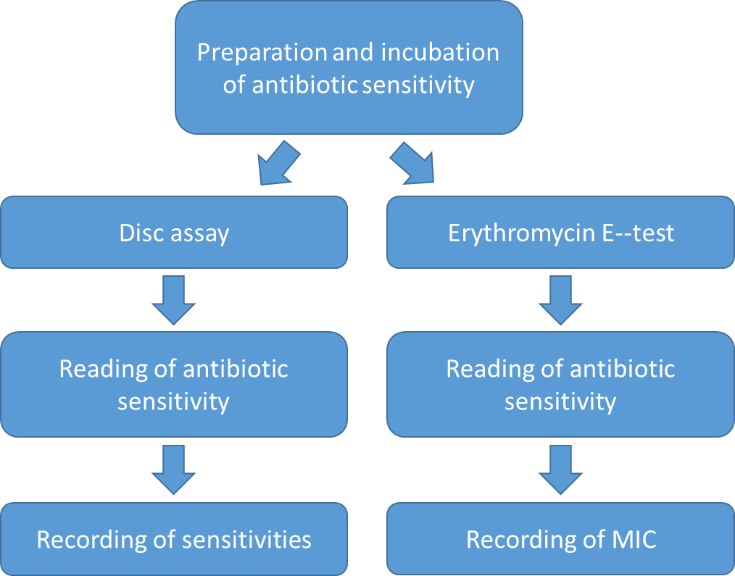 Diagram of workflow: Both a disc assay and an erythromycin E-test will be carried out on each *E.col*i sample to be tested.

# Step-by-step procedures

## Preparation of work area

1. Note: Before starting, ensure all supplies (incl. MHA plates, saline and antibiotic discs discs), are in good condition and not expired. MHA plates should be labeled with plate type (‘MHA’) and date of manufacture/expiration. If plates are not labeled or are expired, do not use. Bring plate and antibiotic discs up to room temperature.
2. Confirm the incubator is at correct temperature (acceptable range: 34-36°C).
3. Clean all working surfaces with 10% bleach.

## Preparation of inoculum

### For each bacterial isolate to be tested label a suspension tube with the clinical isolate to be tested (see SOP 05 *E,coli* culture). In addition, label 1 suspension tube with ATCC 25922 (control strain)

### Make the suspension from overnight growth on non-selective medium (from primary blood agar plate, see SOP 05 *E,coli* culture). In addition, make a suspension of the *E.coli* control strain ATCC 25922 Use several (2-3) morphologically similar colonies (when possible) to avoid selecting an atypical variant and suspend the colonies in saline with a sterile loop or a cotton swab.

### Standardise the inoculum suspension to the density of a **McFarland 0.5 (or 1 if mucoid) standard** using the Remel McFarland Equivalence Turbidity Standard Set. A denser inoculum will result in reduced zones of inhibition and a decreased inoculum will have the opposite effect.

#### Invert the McFarland Equivalence Turbidity Standard gently to fully suspend the polystyrene microparticles

#### Visually compare the turbidity of the bacterial suspension prepared (Note the bacterial suspension tubes should be of similar diameter as the McFarland Equivalence Turbidity Standard tube)

#### For visual comparison use adequate light and read the tubes against the white card with contrasting black lines (Figure 1)

#### Equal obliteration or distortion of black lines indicate turbidity match.

#### [McFarland Standards- Principle, Preparation, Uses, Limitations](https://www.google.com/url?sa=i&url=https://microbenotes.com/mcfarland-standards/&psig=AOvVaw19X4kc9eexO8g2T0zAhspn&ust=1597153326534000&source=images&cd=vfe&ved=0CAIQjRxqFwoTCOCy6PvhkOsCFQAAAAAdAAAAABAD)Bacterial suspension is standardized when distortion of black lines is equal to that of the corresponding McFarland Equivalence Turbidity Standard

Figure 1: McFarland Equivalence Turbidity Standards visualized against a white card with contrasting black lines

### Adjust the density of the organism suspension to McFarland 0.5 (or 1 if mucoid) by adding saline or more organism.

### **The suspension should optimally be used within 15 minutes and always within 60 minutes of preparation.** Always invert the suspension to ensure mixing directly prior to inoculation

## Inoculation of agar plates

### Using a permanent marker, label the bottom of each plate with the details of the bacterial isolate to be inoculated and with ‘AMR’ to indicate that this is the AMR culture plate. Label one plate with positive control ATCC 25922. Labels can also be printed if this option is available.

### Dip a sterile cotton swab into the suspension and remove the excess fluid by turning the swab against the inside of the container. **It is important to remove excess fluid from the swab to avoid over-inoculation of plates**

### Spread the inoculum evenly over the entire surface of the plate by swabbing in three directions (Figure 2). **Take particular care to ensure that there are no gaps between streaks**

Figure 2: streaking of inoculum on agar plate in three directions

### After streaking the plate, dispose the cotton swab in 10% bleach.

### Repeat steps 5.3.2-5.3.3 for all isolates to be tested plus the positive control.

## Application of antibiotic discs

### Make sure that the discs are at room temperature. The disc dispenser should be loaded with the following discs (Table 1)

Table 1: Antibiotic disc concentration:

|  |  |
| --- | --- |
| **Antibiotics to be tested** | **Disc Concentration**  **(µg)** |
| Meropenem | 10 |
| Ceftriaxone | 30 |
| Ciprofloxacin | 5 |
| Ampicillin | 10 |
| Co-trimoxazoleB | 1.25-23.75 |
| Gentamicin | 10 |

### Apply discs within 15 minutes. **If inoculated plates are left at room temperature for prolonged periods of time before the discs are applied, the organism may begin to grow, resulting in erroneous reduction in sizes of zones of inhibition. Discs should therefore be applied to the surface of the agar within 15 minutes of inoculation**

### Apply discs firmly to the surface of the inoculated and dried agar plate using an antibiotic disc dispenser (Figure 3). The contact with the agar must be close and even. Discs must not be moved once they have been applied to plates as diffusion of antimicrobial agents from discs is very rapid.

Figure 3: Applying antibiotic disks with a disk dispenser

### Repeat steps 5.4.1-5.3.2 for all inoculated plates.

### The number of discs on a plate is limited to a maximum of 6 to avoid overlapping of zones and interference between agents. It is important that zone diameters can be reliably measured.

## Incubation of plates

### Invert plates and incubate them within 15 minutes of disc application. If the plates are left at room temperature after discs have been applied, pre-diffusion may result in erroneously large zones of inhibition

### Stacking plates in the incubator may affect results due to uneven heating. The efficiency of incubators varies, but for most incubators, a maximum of five plates per stack is appropriate.

### **Incubation conditions for antimicrobial susceptibility test plates**

|  |  |
| --- | --- |
| **Organism** | **Incubation conditions** |
| *E.coli* | 34 – 36°C in air for 16 – 20 hours |

### Record all necessary information in a lab book, including

#### Lab ID No. (using second printed label)

#### Date AMR plate streaked

#### Time placed into incubator

#### Any relevant observation/incident

## Examination of plates after incubation

### A correct inoculum and satisfactorily streaked plates should result in a confluent lawn of growth

### The growth should be evenly distributed over the plate to achieve uniformly circular (non-jagged) inhibition zones (Figure 4). If individual colonies can be seen, the inoculum is too light and the test must be repeated.

Figure 4: Examples of confluent bacterial plates with antibiotic discs. The growth should be confluent and evenly spread over the plate

### Check that inhibition zones are within quality control limits

## Measurement of zones and interpretation of susceptibility

### For all agents, the zone edge should be read at the point of complete inhibition as judged by the naked eye with the plate held about 30 cm from the eye (Figure 5). Small colonies that are visible should be taken into account when reading zone. The presence of small colonies close to the zone edge may be related to excess humidity in the MHA and may be reduced by drying the plates prior to use

Figure 5: Examples of where to read zone of inhibition with fuzzy edge (see white line)

### Read supplemented plates from the front with the lid removed and with reflected light

### Do not use transmitted light (plate held up to light) or a magnifying glass

### Interpret zone diameters by using the antibiotic template (see appendix). The plate is placed over the clear acetate template and zones interpreted according to the EUCAST breakpoints marked on the template in accordance with the latest version of the EUCAST breakpoint tables. A program for preparation of templates is freely available from http://bsac.org.uk/susceptibility/template-program.

### Discrete colonies growing within the zone of inhibition should be sub-cultured and identified and the test repeated if necessary

### Antagonists in the medium may result in faint growth up to the disc. Such growth should be ignored and the zone diameter measured at the more obvious zone edge.

## Recording of results

### Make sure to read, evaluate and record the control strain results before reporting results for the isolates. The control strain should be sensitive to all antibiotics tested. If there are any discrepancies, record this and repeat the assay. Potential errors are outlined in appendix 3 Record results in logbook and electronically as R-resistant, S-sensitive or I-intermediate (zone of inhibition is less than for resistant, but a zone is visible) according to zone of inhibition (see table 2, https://eucast.org/clinical_breakpoints/)

Table 2: Zone of inhibition for antibiotic discs

|  |  |  |  |  |  |  |
| --- | --- | --- | --- | --- | --- | --- |
| **Antibiotics to be tested** | **Disc Concentration**  **(µg)** | **EUCAST Zone of inhibition (mm)**  **S> R<** | | **CLSI Zone of inhibition (mm)**  **S> I R<** | | |
| Meropenem | 10 | 22 | 16 | >23 | 20-22 | <19 |
| Ceftriaxone | 30 | 25 | 22 |  |  |  |
| Ciprofloxacin | 5 | 25 | 22 | >26 | 22-25 | <21 |
| Ampicillin | 10 | 14 | 14 | >17 | 14-16 | <13 |
| Co-trimoxazole | 1.25-23.75 | 14 | 11 | >16 | 11-15 | <10 |
| Gentamicin | 10 | 17 | 17 | >15 | 13-14 | <12 |

## Azithromycin E-test

### Antibiotic resistance to erythromycin will be tested by E-test.

### Allow E-test strips to reach room temperature prior to opening Make sure that strips were protected from moisture, heat and direct exposure to strong light at all times. Ensure that moisture has not penetrated within the package or storage container and that strips were kept dry with active desiccant. Only use strips which have been stored correctly. Once strips have reached room temperature ensure that moisture condensing on the outer surface has evaporated completely before opening the package

### Prepare a 0.5 (or 1 if mucoid) McFarland suspension from the appropriate AMR plate according to 5.2. Set up a separate suspension for the control strain *E.coli* ATCC 25922. If the previous suspension used in 5.3 is less than 60min old, this can be used and no new suspension is needed

### Inoculate MHA plates as described in 5.3. Allow excess moisture of the inoculum to be absorbed for approximately 15 minutes so that the surface is completely dry before applying the gradient strips.

### Check that the inoculated agar surface is completely dry before applying gradient strips. Strips can be applied to the inoculated agar surface with forceps. Position the gradient strip with the MIC scale facing upwards (towards the opening of the plate) and the concentration maximum nearest the rim of the plate. Ensure that the whole strip is in complete contact with the agar surface. Do not place the strip upside down as no inhibition ellipse will form since the antibiotic will not diffuse across the non-porous plastic strip. If air pockets are seen under the strip, remove them by pressing gently on the strip (without moving it) with the applicator tip or forceps, working from the lowest concentration upwards. Small bubbles will not affect results. Once applied, the strip cannot be moved because of instantaneous release of antibiotic into the agar.

### Incubate the agar plates in an inverted position (lid down) in stacks no higher than 5 at 34-36oC for 16-20 hours

### streipguideAfter the required incubation period and only when an even lawn of growth is distinctly visible, read the MIC value where the pointed end of the inhibition ellipse intersects the side of the strip. Do not read the plate if the culture appears mixed or if the lawn of growth is too light or too heavy; repeat the test. Gradient MIC endpoints are usually clear-cut although different growth/ inhibition patterns may be seen (Figure 6 and 7).

Figure 7: Organism, antibiotic, resistant mechanism and handling effects on MIC

Figure 6 Reading the minimum inhibition concentration (MIC)

|  |  |  |
| --- | --- | --- |
| TYPE OF EFFECT | EFFECT/ORGANISM | COMMENT |
| Resistance Mechanism | Resistant subpopulations | Read MIC at 100% inhibition |
| Resistance Mechanism | Low-level mutations | Read MIC as resistant if isolated colonies are within the ellipse spanning the gradient |
| Technical and Handling | Intersection between markings | Read next higher MIC |
| Technical and Handling | Different intersections on either side of the strip | Read the higher MIC |
| Technical and Handling | Thin line of growth along the edge of the strip | Ignore this growth caused by organisms growing up a tunnel of water. |

### Record MIC in logbook and electronically. MIC of the control strain *E.coli* ATCC 25922 should be recorded. If the MIC for the control strain differs, repeat the assay.

### Storage of bacteria

#### With a permanent marker label 1 vial per isolate with ID, vial 14.

#### With a 10μl bacterial loop take a sweep from the AMR plate and under aseptic conditions open the screwcap of the storage vial and inoculate the cryopreservative fluid by twisting the loop in the fluid multiple times. Make sure not to spill the fluid.

#### Close the lid of the storage vial tightly and invert 4-5 times to mix and bind the bacteria to the beads. Do not vortex.

#### Make sure that you have recorded which vials will be stored in the logbook and then freeze the vials at -80oC. Record where vials were frozen (position in cryobox, cyrobox number, position in freezer in the log book)

# Occupational Safety Issues

## The Principal Investigator must ensure that all study team members undertaking this SOP are trained in good clinical laboratory practice

## Handle all specimen and cultures with care and treat them as potentially infectious material. Always wear appropriate PPE

# Quality Assurance / Quality Control

## Ensure MHA plates are labelled with plate type (MHA) and expiration date.

## For all new kits/supplies, record batch numbers in the lab book.

## Loss of potency of antimicrobial agents in discs results in reduced zone diameters and is a common source of error. The following are essential.

### Stored discs, including those in dispensers, in sealed containers with a desiccant and protected from light

### Store disc stocks at 5-8oC unless otherwise indicated by the supplier

### Store working supplies of discs (discs in use) at <8°C

### To prevent condensation, allow discs to warm up to room temperature before opening containers

### Discard discs on the manufacturer’s expiry date shown on the container

## For all AMR testing *E.coli* ATCC 25922 should be used as a control

# Appendices and other related documents

| **Document number** | **Document content** |
| --- | --- |
| <https://www.eucast.org/fileadmin/src/media/PDFs/EUCAST_files/Disk_test_documents/2020_manuals/Slide_show_v_8.0_EUCAST_Disk_Test_2020.pdf> | EUCAST disc test slides |
| <https://www.eucast.org/fileadmin/src/media/PDFs/EUCAST_files/Disk_test_documents/2020_manuals/Manual_v_8.0_EUCAST_Disk_Test_2020.pdf> | EUCAST disc test manual |
| <https://eucast.org/clinical_breakpoints/> | EUCAST breakpoints |
| Appendix 1 | Antibiotic susceptibility template |
| Appendix 2 | Storage and subculture of control strain |
| Appendix 3 | Potential source of error for disk diffusion test |
| Appendix 4 | Preparation of MHA plates |

# Version history, authors and approvals

| **Version (date)** | **Edits to the SOP text (author)** |
| --- | --- |
| 1.0 (2022-06-22) | Authored by Dagmar Alber and Elaine Cloutman-Green, approved by LAKANA PSG. |

# Appendix 1

###### **Antibiotic susceptibility templates**

EUCAST templates are generated by a computer program provided by BSAC. Original printouts are used, not photocopies as distortion may occur with copying. The program can be downloaded from <http://www.bsac.org.uk/susceptibility/template-program/> follow the online help provided with the program for help.

Templates are used in sensitivity determination by zone size comparison. After each template is printed, it is measured with a calibrated ruler to confirm that the template sizes are exact measurements.



Example template

## Appendix 2

### **Storage and subculture of control strain**

### Store control strains on beads at -70°C. Store two vials of each strain, one for in-use and one as an archive.

### Each week, subculture from the in-use vial onto appropriate non-selective media and check for purity.

### Each day of the week, prepare a subculture from the purity plate. Use several colonies to avoid selecting a mutant.

### QC strains may be subcultured for a maximum of 6 days. Then, discard plates and prepare a new purity plate form the frozen in-use vial.

### When the in-use vial is depleted, subculture from the archive vial and prepare another in-use vial from the subculture

## Appendix 3

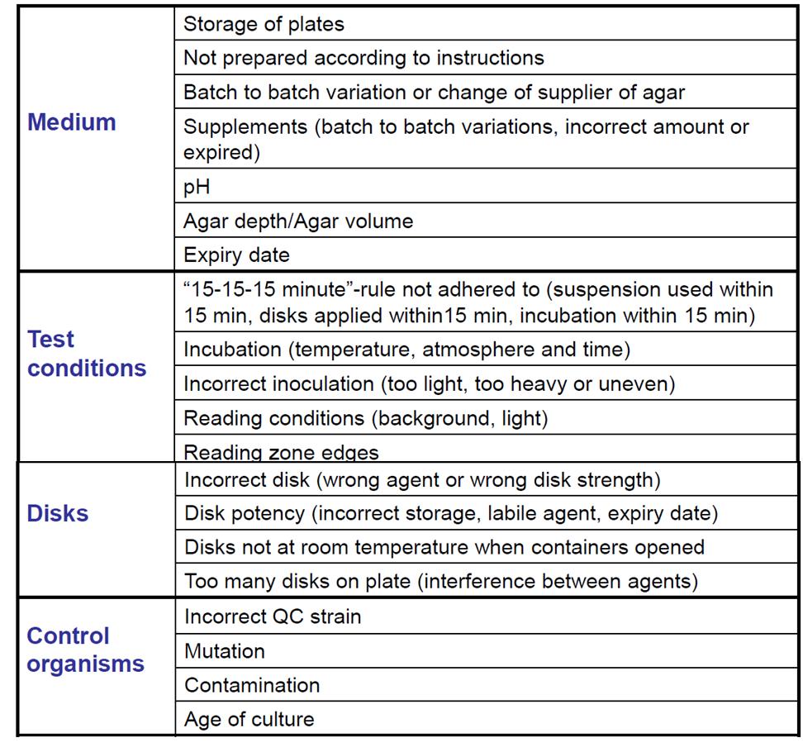Potential source of error for disc diffusion test according to <https://www.eucast.org/fileadmin/src/media/PDFs/EUCAST_files/Disk_test_documents/2020_manuals/Slide_show_v_8.0_EUCAST_Disk_Test_2020.pdf>

## Appendix 4

**Preparation of MHA plates**

### Agar plate preparation

#### Prepare and autoclave MH agar according to the manufacturer’s instructions

#### Cool medium to 42-45°C

#### Dispense medium into sterile Petri dishes to give a level depth of 4 + 0.5 mm (approximately 25 mL in a 90 mm circular plate, 31 mL in a 100 mm circular plate, 71 mL in a 150 mm circular plate, 40 mL in a 100 mm square plate). Ascertain that a correct volume, based on the true dimensions of the Petri dish in use, is calculated. Plate dimensions may differ between manufacturers

#### Allow the agar to set before moving the plates

#### The surface of the agar should be dry before use. No drops of water should be visible on the surface of the agar or inside the lid. If necessary, dry plates either at 20-25°C overnight, or at 35°C, with the lid removed, for 15 min. Do not over-dry plates.

#### Label plates with MHA and date