Standard Operating Procedures for the LAKANA trial

**SOP Lab-05 *E. coli* culture**

Version 1.0 (2022-06-22)

# Purpose and overview:

This Standard Operating Procedure (SOP) explains how to grow and identify *Escherichia coli* (*E.coli*) from rectal specimen stored in Cary Blair media.

# Applicability to and responsibilities of various staff members

|  |  |
| --- | --- |
| **Staff member** | **Responsibility** |
| Laboratory technician/scientist | * Maintaining sufficient supply of culturing materials in the testing laboratory * Culture and storage of *E. coli* from Cary Blair transport media using good aseptic technique * Recording results |

# Required materials

| **Item** | **Number** | **Specification** |
| --- | --- | --- |
| Disinfectant | 500-1000 mL | 10% bleach and 70% alcohol |
| Primary culture plates | 1/sample | Coliform ChromoSelect Agar, e.g. Merck 81938-500G-F |
| Secondary culture pates | 1/sample | Tryptone Soya Agar (TSA) (such as Oxoid Product Number: CM0131) |
| Indole spot reagent | 1 drop | For *E. coli* confirmation testing (such as Thermofisher product number R21245) |
| Filter paper | 1/sample | For indole spot test (such as Whatman filter paper Sigma Aldrich product number WHA1001055) |
| Inoculation loops | Number required for plating and making slides | For plating and making slides for Gram Stain |
| Cryobox | Number required for storing plates | None |

1 Abbreviations: AMR = Antimicrobial resistance, COVID-19 = coronavirus disease 2019, DESS = DMSO/EDTA/saturated sodium chloride, LAKANA = Large-scale assessment of the key health-promoting activities of two new mass drug administration regimens with azithromycin, DCF = Data collection form, NPS = nasopharyngeal swab, PID = participant identification, PPE = personal protective equipment, SOP = Standard operating procedure, TSA = tryptone soya agar

| **Item** | **Number** | **Specification** |
| --- | --- | --- |
| Incubator | 1 | Ambient air up to 5% CO2, 36±1°C |
| Micropipettes | Number required | Ability to obtain 400ul |
| Permanent laboratory marker | 1 | None |
| Gram’s Iodine | Well Supplied in labs performing Gram Staining | To use in Gram Staining |
| Crystal Violet | Well Supplied in labs performing Gram Staining | To use in Gram Staining |
| Carbol-fuchsin | Well Supplied in labs performing Gram Staining | To use in Gram Staining |
| Acetone Alcohol | Well Supplied in labs performing Gram Staining | To use in Gram Staining |
| Water | Amount required | To use in Gram Staining |
| Sterilized Saline | Well Supplied in labs performing Gram Staining | To use in Gram Staining |
| Specimen labels | Number required | None |
| Bacterial storage bead vials Cryopreservation medium: TSB with 15-20% glycerol (sterile), 1ml aliquots in cryovials | Well supplied | for bacterial stock preservation at -800C Freezer |

# Definitions and general instructions

## Definitions:

### Laboratory technician/scientist: a staff member in the laboratory responsible for LAKANA study.

## General Instructions:

### The flow-chart of the main steps in this SOP is shown below. The detailed instructions for each step are described in Section 5 Step-by-step procedures.

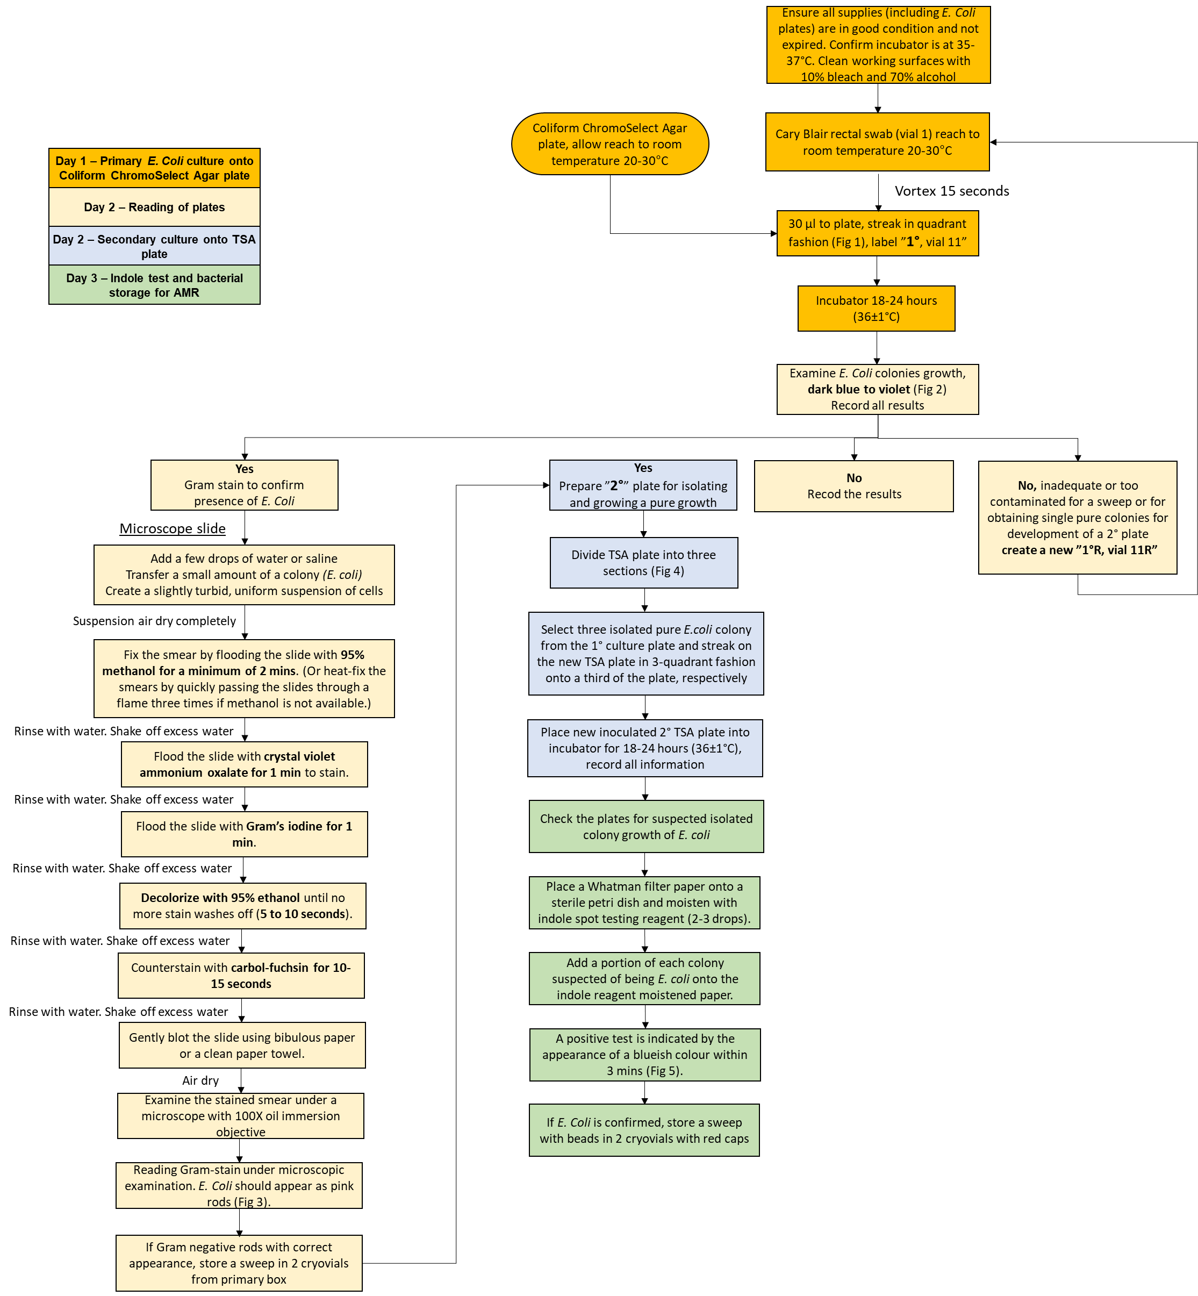

### The following samples will be stored

|  |  |  |  |
| --- | --- | --- | --- |
| **Plate** | **Type** | **storage** | **Vial No** |
| 10 | sweep | Yes | Vial 11, 10 CHROM Gram ne, ID, date (section 5.4.17) |
| 20 | Enough for 0.5 McFarland standard | No, carry on with AMR | N/A |
| 20 | sweep | Yesa | Vial 12, 20 TSA, *E.coli,* ID, date (section 5.6.5.3) |

# Step-by-step procedures

## Preparation of work area

### Before starting, laboratory technician will ensure all supplies (incl. *E. coli* plates) are in good condition and not expired. *E. coli* plates should be labeled with plate type (‘Coliform ChromoSelect Agar, TSA’) and date of manufacture/expiration. If plates are not labeled or are expired, do not use.

### Laboratory technician will confirm that the incubator is at correct temperature (acceptable range: 35-37°).

### Laboratory technician will clean all working surfaces with 70% alcohol and 10% bleach before starting and in between the lab work if needed.

## Day 1 Primary *E.coli* culture Coliform ChromoSelect Agar plates

### Remove Coliform ChromoSelect Agar plates (1 per specimen) from the refrigerator and lay them on the bench surface and allow plates to reach room temperature (20-30°C).

### Remove selected Cary Blair rectal swab samples (labelled vial 1) from 2-8°C refrigeration, if stored for less than 48 hours or the -80oC freezer. Place these in a clean rack on the bench.

### Using a permanent marker, label the bottom of each plate (the part containing the agar) with the details of the specimen to be inoculated and with ‘1o’ and ‘vial 7’ to indicate that this is the primary culture plate. Labels can also be printed if this option is available.

### Stack the labeled non-inoculated Coliform ChromoSelect Agar plates on the bench; ensuring the order of the stack corresponds to the order of the specimen samples to be used.

### Allow Cary Blair specimen to reach room temperature (20-30°C). Limit time samples are at room temperature and store samples in the refrigerator until culture is completed to avoid freeze thaw cycles. Once culture and identification is completed, freeze back sample at -80oC.

### Vortex each specimen for 15 seconds.

### Open a single Cary Blair specimen sample, maintaining precautions to minimize risk of contamination.

### Using a sterile 10µl plastic inoculation loop, take 3 full loops (30µl) of samples and place the inoculum on the same spot on the plate before starting to streak. Streak this, in quadrant fashion, on the Coliform ChromoSelect Agar plates (Fig 1)

Fig 1: Quadrant streak method

### .

### Dispose of the inoculation loop in 10% bleach.

### Replace the lid on the inoculated culture plate and set, upside down (agar side on top, lid on bottom), on the bench apart from the non-inoculated plates.

### Repeat steps 5.2.6.-5.2.9. with remaining cryovials of thawed Cary Blair samples until all have been plated, all the time **ensuring Lab ID No. on Coliform ChromoSelect Agar plate corresponds Lab ID No. on 2ml vial**.

### Place all inoculated 1° culture plates, agar side up, into the incubator for 18-24 hours (36±1°C). Do not place more than 8 plates in a single stack.

### Record all necessary information in the lab book, labeled including

#### Lab ID No. (using second printed label)

#### Date 1° culture plate streaked

#### Time placed into incubator

#### Any relevant observation/ incident

## Day 2: Reading of Coliform ChromoSelect Agarplate

### Confirm the incubator is at correct temperature (36±1°C).

### Clean all working surfaces with 10% bleach or 70% alcohol.

### Remove all 1° plates from the incubator and lay these on the bench.

### Examine individual 1° culture plates for growth of *E. coli* colonies which will appear as dark blue to violet coloured colonies (Fig. 2: different bacterial colonies on Coliform ChromoSelect Agar plates media, while other coliforms appear as salmon to red colonies, Gram positive bacteria are inhibited).

Fig 2: *E.coli* colonies appear dark blue to violet coloured, other coliforms appear salmon to red and Gram positive bacteria are inhibited

### **Note, Re-plating 1° Plate**: If the growth on the 1° plate does not include dark blue-to violet coloured colonies, is inadequate or too contaminated for a sweep or for obtaining single pure colonies (for development of a 2° plate), create a new 1° culture plate. Repeat the procedure as outlined above adding more or less of the sample as indicated by the first 1° plate (avoiding contaminants). Quadrant streak onto Coliform ChromoSelect Agar *E. coli* as above. Label this plate ‘1°R’ and ‘vial 7R’ (Re-plated) and place in incubator.

### Record results of the 1° culture plate in the lab book, labeled, including:

#### Time 1° culture plate was taken out of incubator

#### Date 1° culture plate was read

#### Growth type (incl. No Growth, color, colony margins, shape). Record all growth types on 1° culture plate, even if replating 1° culture plate.

#### 1° plate outcome (*E. coli* cultured)

#### Any relevant observation/ incident (incl. re-plating if performed)

#### **Note:** Record all growth types, even if re-plating

## Gram Stain to Confirm Presence of *E. Coli* (Gram negative bacteria)

### With a bacterial loop add a few drops of saline to a microscope slide

### With a fresh loop aseptically transfer a small amount of a colony presumed to be *E. coli* to the wetted part of the microscope slide to create a slightly turbid, uniform suspension of cells

### Let the suspension air dry. The suspension MUST be completely dry before proceeding.

### Fix the smear by the flooding the slide with 95% methanol for a minimum of 2 minutes. Rinse with water. Shake off excess water.

### If methanol is not available, heat-fix the smears by quickly passing the slide through a flame three times. Do not over-heat the slide as over-heating will cause significant distortion or destruction of the cells.

### Flood the slide with crystal violet ammonium oxalate for 1 minute to stain. Rinse with water. Shake off excess water.

### Avoid touching the slide with the tip of the reagent bottle or applying liquid directly onto the smear.

### Flood the slide with Gram’s iodine for 1 minute. The iodine acts as a mordant as it binds the alkaline crystal violet dye to the cell wall. Rinse with distilled water. Shake off excess water.

### Briefly flood the slide evenly with Acetone Alcohol for 5 – 10 seconds being aware that over decolourisation will lead to false readings. Rinse with water. Shake off excess water.

### It is essential to view decolorization closely: Gram-positive bacteria can be made to appear Gram-negative by over-decolorization and Gram-negative bacteria can be made to appear Gram-positive by under decolorization.

### Counterstain with carbol-fuchsin for for up to 1 minute. Rinse with water. Shake off excess water.

### Gently blot the slide using bibulous paper or a clean paper towel. Let air dry

### When dry, examine the stained smear under a microscope with 100X oil immersion objective.

### Reading Gram-stain under microscopic examination (Fig 3)

#### *E.coli* should appear as .pink rods

Fig 3: *E.coli* colonies appear rod shaped and pink after Gram staining

### Record the results in the lab book, labeled including

#### Pure or mixed culture

#### Shape (cocci, rod, etc.)

#### Gram negative or positive

### If Gram negative rods with correct appearance on Coliform ChromoSelect Agar *E. coli* plate, proceed making of a 2° plate , a TSA plate for storage and *E. coli* confirmation.

### Storage of bacteria

#### Laboratory personnel will print two barcode labels (or label with a permanent marker) and affix them to 2 vials for *Gram negative* sweep with ID, 1o Coliform ChromoSelect plate, visit number, date and vial number.

#### With a 10μl bacterial loop take a sweep from the 1o plate and under aseptic conditions open the screwcap of the storage vial and inoculate the cryopreservative medium by twisting the loop in the fluid multiple times. Make sure not to spill the fluid.

#### Close the lid of the storage vial tightly and invert 4-5 times to. Do not vortex.

#### Make sure that you have recorded which vials will be stored in the logbook and then freeze the vials at -80oC. Record where vials were frozen (position in cryobox, cyrobox number, position in freezer in the log book)

## Secondary culture onto TSA

### If there are 1° plates with dark blue to violet colonies suspect of *E. coli*, prepare 2° plates for isolating and growing a pure growth. If no dark blue to violet colonies, do not proceed further and consider *E.coli* not to be present.

### Image result for agar plate divided in thirdsUsing a permanent marker, draw 3 distinct areas on the back of the plate to plate 3 individual isolates onto the same TSA plate (see Fig 4).

Fig 4: Divide TSA plate into sections

### Using a permanent marker, label the bottom of the TSA plates with ‘2°’ (to signify this is a 2° culture plate and not, for example, a 1° plate).

### Label each section of the TSA plate to be streaked with the details of the 1o plate. Labels can also be printed if this option is available. Stack the labeled non-inoculated TSA plates on the bench, ensuring the order of the stack corresponds to the order of the samples to be used.

### Using a sterile 10µl plastic inoculation loop, select one isolated pure *E. coli* colony, based on colony morphology, from the 1° culture plate and streak on the new TSA plate in 3-quadrant fashion onto a third of the plate.

### Replace the lid on the inoculated 2° culture plate and set agar on the bench apart from the non-inoculated plates.

### Repeat steps 5.5.5-5.5.6 with remaining plates until all 1° plates have been plated as 2° culture plates, all the time ensuring Lab ID No. on 1° plate corresponds to lab ID No. on 2° plate.

### Place all newly inoculated 2° culture plates up-side down into incubator, for 18-24 hours (36±1°C)

### Record all necessary information in the lab book, labeled, including

#### Date 2° culture plate streaked

#### Time 2° culture plate placed into incubator

#### Any relevant observation/ incident (include any “atypical” growth patterns)

## Day 3: Indole test and bacterial storage

### Confirm the incubator is at the correct temperature (36±1°C).

### Clean all working surfaces with 10% bleach or 70% alcohol.

### Remove all 2° plates from the incubator and lay these on the bench.

### Check the 2° plates for suspected isolated colony growth of *E. coli.*

### Indole testing and storing *E. coli* for AMR testing

#### Place a Whatman filter paper onto a sterile petri dish and moisten with indole spot testing reagent (about 2-3 drops). Using a sterile plastic inoculating loop, add a portion of each colony suspected of being *E. coli* onto the indole reagent moistened paper. A positive test is indicated by the appearance of a blueish colour development within 3 minutes (Fig 5). Note: more than one colony can be tested per filter paper if there is appropriate space for reagent to be added without touching another isolate being tested.

Fig 5: Indole test showing a positive result- colour change to blue

#### If *E. coli* is confirmed by a positive indole result, store a sweep (from the TSA plate) and proceed with AMR testing. Do not store indole negative colonies or colonies that were not blue in appearance on the 1°plate.

#### Prepare 2 cryovials as described in 5.4.17 labelling the vials with ID, *E.coli* isolate, visit , date and vial number

### After isolates are stored into cryovials, dispose of all plates in a biosafety bin.

# Occupational Safety Issues

## The Principal Investigator must ensure that all study team members undertaking this SOP are trained in good clinical laboratory practice

## Handle all rectal specimen with care and treat them as potentially infectious material.

# Quality Assurance / Quality Control

## Ensure *E. coli* plates are labelled with plate type (incl.: Coliform ChromoSelect, , TSA) and expiration date.

## Always check plates before inoculation for indication of contamination.

## Following incubation, inspect plates for unusual growth indicating contamination.

## Do not use media beyond expiry dates and maintain lot numbers and expiry dates in the lab book.

## Always use aseptic technique when opening tubes, plating, and transferring colonies to reduce contamination.

## For all new kits/supplies, record Batch Numbers in the lab book.

# Version history, authors and approvals

| **Version (date)** | **Edits to the SOP text (author)** |
| --- | --- |
| 1.0 (2022-06-22) | Authored by Dagmar Alber, Elaine Cloutman-Green and Yuemei Fan, approved by LAKANA PSG. |